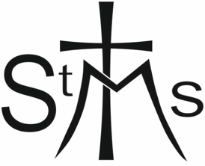

COMPLIANCE WITH NEW GENERAL DATA
PROTECTION REGULATION (MAY 2018)

In order to comply with the new General Data Protection Regulation being brought into UK law in May 2018, it is necessary for you to give permission for the Church of St. Mary, the Virgin, Richmond (North Yorkshire) to keep your personal information on file.
It would, therefore, be appreciated if you would read the following statement and sign below giving your consent to this.
‘I agree that the Confidential Declaration Form that I have completed as a requirement of our Parish Safeguarding Procedure may be filed safely in accordance with the conditions stipulated in the Data Protection Act. I understand that the document will be kept whilst necessary for safeguarding purposes’

FULL NAME: ………………………………………………………………………………………….
SIGNATURE: ……………………………………………………………………………..
DATE: ….………………………………………..

